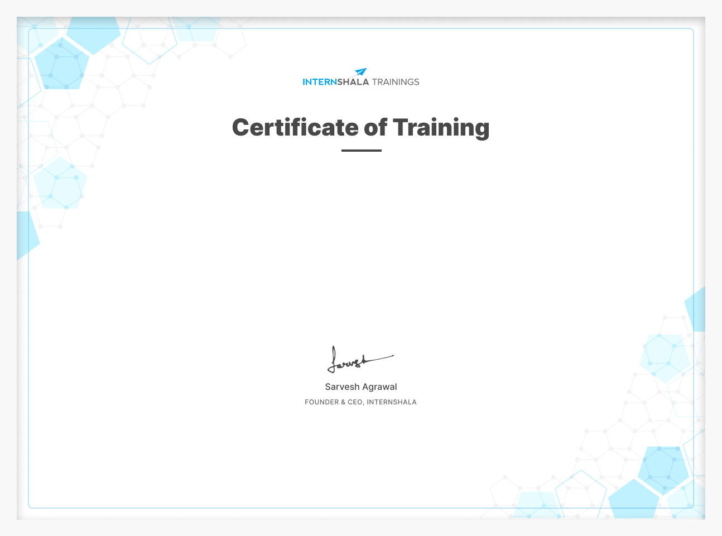

Abhishek Kumar Giri

has successfully completed an 8-week online training on **Web Development**. The training consisted of HTML, CSS, Bootstrap, DBMS, PHP, JS, React, Final Project, and AI in Web Development modules.

Abhishek is a top performer in the training.

We wish Abhishek all the best for future endeavours.

Date of certification: 2024-08-25 Certificate no. : i03tdwtocmt For certificate authentication, please visit [https://trainings.internshala.com/verify_certificate](https://trainings.internshala.com/verify_certificate?certificate_number=i03tdwtocmt)